Full Load Prod -> erpapp01 10.10.130.31

Contents

1. Introduction 2

2. Got minus one from a read call 2

3. Full load Execution Fails 4

3.1 Solution 1 4

3.2 Solution 2 4

3.2.1 Duplicates in W_DOMAIN_MEMBER_MAP_G 5

3.2.2 Duplicates in W_EMPLOYEE_DS 8

3.2.3 Duplicates in W_PRODUCT_ATTRIBS_D 11

3.2.4 Duplicates in W_STATUS_D 14

3.2.5 Duplicates in W_PRODUCT_D 18

3.2.6 Duplicates in W_PROC_PROD_D 22

4. TEMP Table Space full 27

5. End of Full Load 28

6. Checking the execution of the customized tasks 28

6.1 SDE PROCPO Fact Group 28

6.2 SDE PURAGG Fact Group 29

6.3 SDE OP Fact Group 29

6.4 SDE PROCPURRCPT Fact Group 30

6.5 SDE PROCPURREQ Fact Group 30

6.6 SIL PROCPO Fact Group 31

6.7 SIL PROCPURREQ Fact Group 31

6.8 SIL PROCPURCY Fact Group 32

7 Purchase Cost Fact Obtain the Original Promised Date 33

# Introduction

During a full load session of ODI using Oracle EBS as a source, following are the errors occurred, after looking to different articles and BLOGs, we were unable to find a proper solution.

One of the work around is to delete the duplicate rows cause failure and re-start the Execution Plan. We are doing this workaround since we install OBI in MBC.

The other work around is to enable the split table configuration. It will create another table with the same structure but will store only duplicate rows whenever it occur and throw no error during full load cycle. This solution is good as far as we know that as first solution we are deleting these duplicate records, in this solution instead of deleting those duplicate records it will be store as separate split table.

# Got minus one from a read call

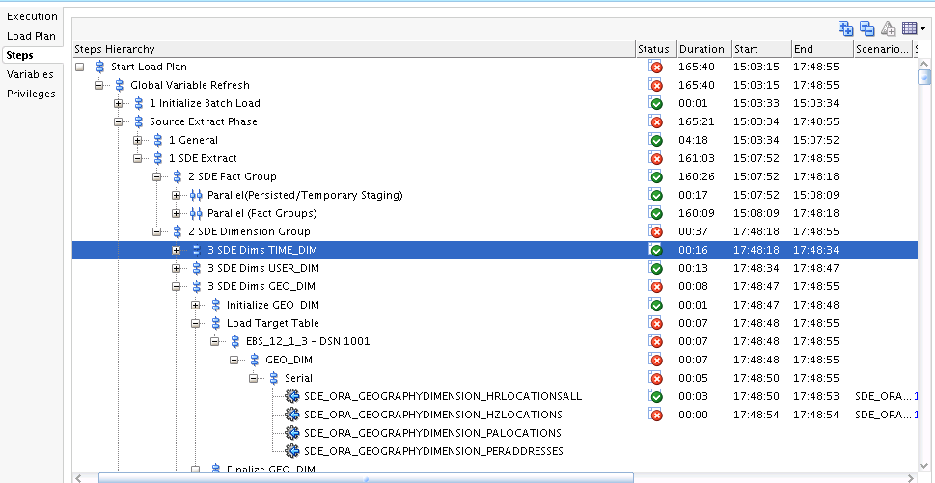

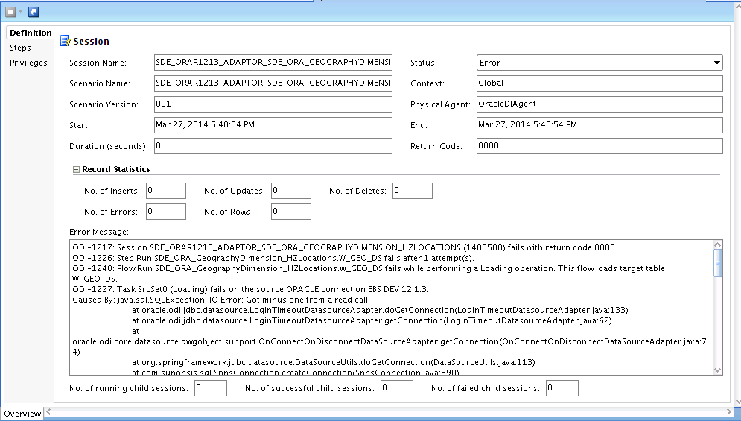

Launching the Load Again from BIACM

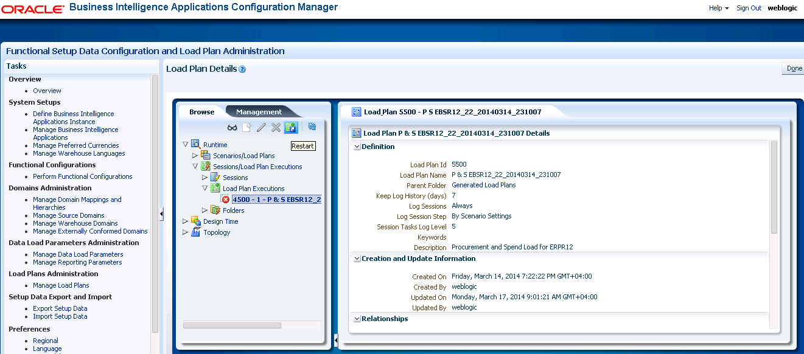

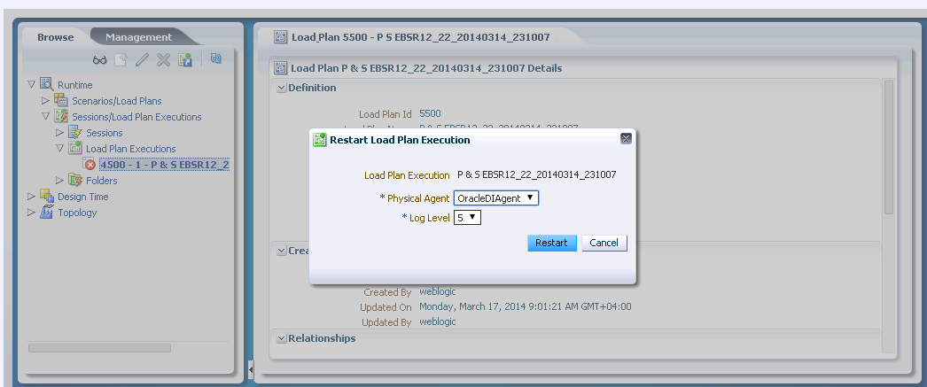

# Full load Execution Fails

When a full load runs , it fails on different task with duplicate index keys insert in the tables exception, after searching of articles and blogs , there are two work around found.

## 3.1 Solution 1

In ODI Studio, open the interface causing the issue, go to the flow tab, select the target data store, and in the KM options that will appear in the property inspector set FLOW_CONTROL to “true”. Save and generate the scenario. Next run full load execution again, any records that violate constraints will be set aside in an E$_<tablename> error table, and an overview of the errors can be found in SNP_CHECK_TABLE. As in the below snapshot.

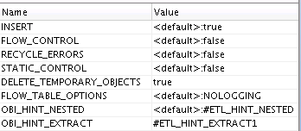

## 3.2 Solution 2

Delete the duplicate records from table and re-start the execution plan which define as below.

### 3.2.1 Duplicates in W_DOMAIN_MEMBER_MAP_G

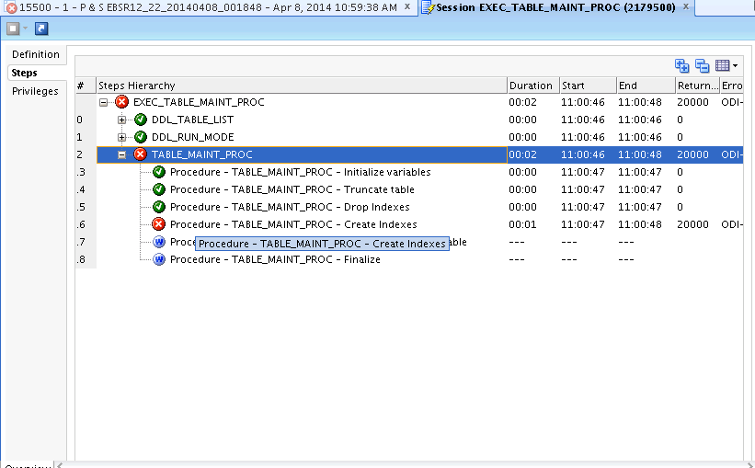

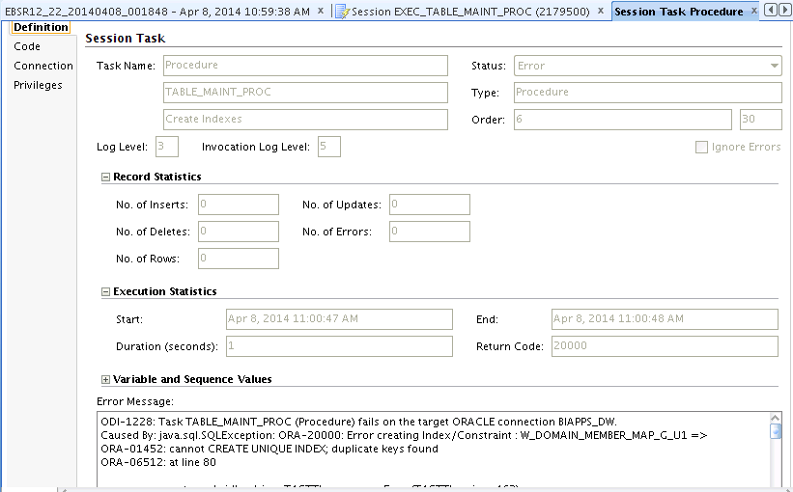

Unique indexing defined as below table;

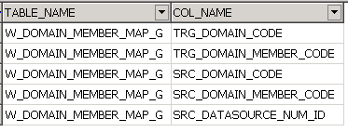

CREATE UNIQUE INDEX PROD_DW.W_DOMAIN_MEMBER_MAP_G_U1 ON PROD_DW.W_DOMAIN_MEMBER_MAP_G (SRC_DOMAIN_CODE,SRC_DOMAIN_MEMBER_CODE,SRC_DATASOURCE_NUM_ID,TRG_DOMAIN_CODE,TRG_DOMAIN_MEMBER_CODE) NOLOGGING;

select count('X'), SRC_DOMAIN_CODE,SRC_DOMAIN_MEMBER_CODE,SRC_DATASOURCE_NUM_ID,TRG_DOMAIN_CODE,TRG_DOMAIN_MEMBER_CODE

from PROD_DW. W_DOMAIN_MEMBER_MAP_G

group by SRC_DOMAIN_CODE,SRC_DOMAIN_MEMBER_CODE,SRC_DATASOURCE_NUM_ID,TRG_DOMAIN_CODE,TRG_DOMAIN_MEMBER_CODE

having count('X') > 1;

**--+500 registers!!**

CREATE TABLE XX_W_DOM_MEMB_MAP_G_20140327 as select * from W_DOMAIN_MEMBER_MAP_G;

DECLARE

l_count NUMBER;

BEGIN

***DBMS_OUTPUT.put_line*** ('******************************Start ***************************');

for jj in (select count('X'), SRC_DOMAIN_CODE,SRC_DOMAIN_MEMBER_CODE,SRC_DATASOURCE_NUM_ID,TRG_DOMAIN_CODE,TRG_DOMAIN_MEMBER_CODE

from PROD_DW.W_DOMAIN_MEMBER_MAP_G

group by SRC_DOMAIN_CODE,SRC_DOMAIN_MEMBER_CODE,SRC_DATASOURCE_NUM_ID,TRG_DOMAIN_CODE,TRG_DOMAIN_MEMBER_CODE

having count('X') > 1) loop

FOR i IN (SELECT emp.ROWID ROW_ID,emp.*

FROM PROD_DW.W_DOMAIN_MEMBER_MAP_G emp

where SRC_DOMAIN_CODE = jj. SRC_DOMAIN_CODE

AND SRC_DOMAIN_MEMBER_CODE = jj. SRC_DOMAIN_MEMBER_CODE

AND SRC_DATASOURCE_NUM_ID = jj. SRC_DATASOURCE_NUM_ID

AND TRG_DOMAIN_CODE = jj. TRG_DOMAIN_CODE

AND TRG_DOMAIN_MEMBER_CODE = jj.TRG_DOMAIN_MEMBER_CODE

)

LOOP

l_count := 0;

SELECT COUNT ('X')

INTO l_count

FROM PROD_DW. W_DOMAIN_MEMBER_MAP_G

WHERE SRC_DOMAIN_CODE = i. SRC_DOMAIN_CODE

AND SRC_DOMAIN_MEMBER_CODE = i. SRC_DOMAIN_MEMBER_CODE

AND SRC_DATASOURCE_NUM_ID = i. SRC_DATASOURCE_NUM_ID

AND TRG_DOMAIN_CODE = i. TRG_DOMAIN_CODE

AND TRG_DOMAIN_MEMBER_CODE = i.TRG_DOMAIN_MEMBER_CODE

group by SRC_DOMAIN_CODE,SRC_DOMAIN_MEMBER_CODE,SRC_DATASOURCE_NUM_ID,TRG_DOMAIN_CODE,TRG_DOMAIN_MEMBER_CODE ;

IF l_count >1

THEN

DELETE FROM PROD_DW. W_DOMAIN_MEMBER_MAP_G WHERE ROWID = i.ROW_ID;

l_count := 0;

***DBMS_OUTPUT.put_line*** (' SRC_DOMAIN_CODE ->'||i. SRC_DOMAIN_CODE || ' SRC_DOMAIN_MEMBER_CODE ->' ||i. SRC_DOMAIN_MEMBER_CODE || ' SRC_DATASOURCE_NUM_ID ->'

||i. SRC_DATASOURCE_NUM_ID || ' TRG_DOMAIN_CODE -> '||i. TRG_DOMAIN_CODE

|| ' TRG_DOMAIN_MEMBER_CODE -> '||i.TRG_DOMAIN_MEMBER_CODE);

*-- COMMIT;*

END IF;

END LOOP;

end loop;

***DBMS_OUTPUT.put_line*** ('****************************** End ***************************');

END;

The DBMS output contains more than 3000 records



COMMIT;

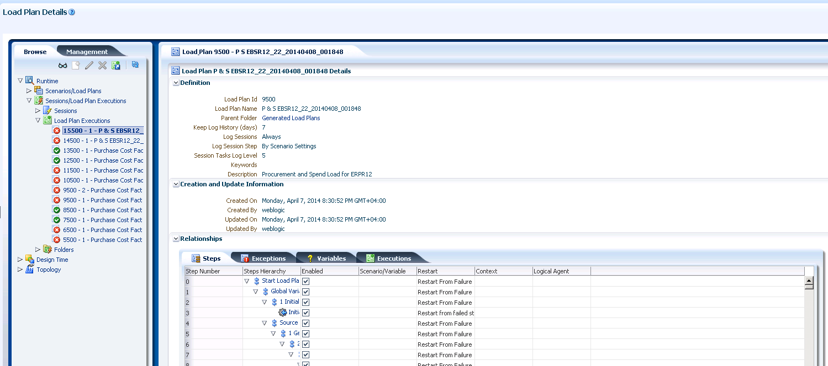

### 3.2.2 Duplicates in W_EMPLOYEE_DS

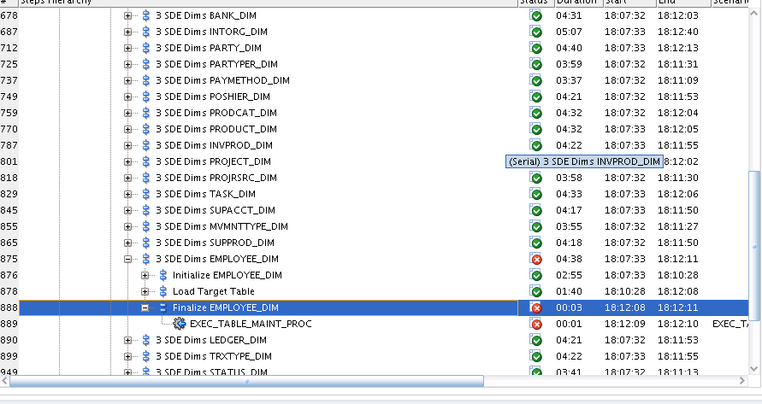

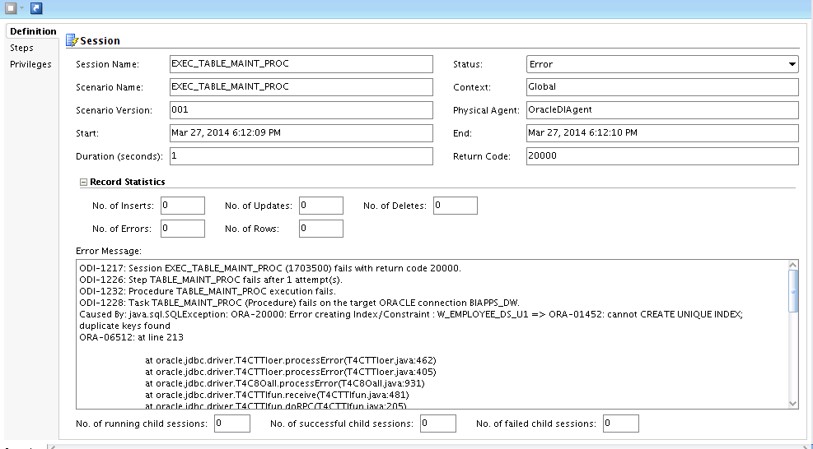

Unique index defined as following table.

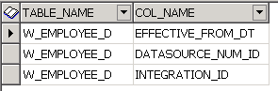

select count('X'),INTEGRATION_ID,DATASOURCE_NUM_ID,SRC_EFF_FROM_DT f

from PROD_DW.W_EMPLOYEE_DS group by INTEGRATION_ID,DATASOURCE_NUM_ID,SRC_EFF_FROM_DT having count('X') > 1;

COUNT('X') INTEGRATION_ID DATASOURCE_NUM_ID F

2 PER~1478 1001 10/11/2009

2 PER~1204 1001 1/1/2012

2 PER~29752 1001 3/23/2012

2 PER~35143 1001 3/1/2014

2 PER~768 1001 12/26/2011

2 PER~27411 1001 10/13/2011

2 PER~1336 1001 11/9/2011

2 PER~29752 1001 11/17/2011

One of the case from ODI generated query, return following results for PER~1336

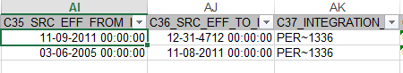

Which is only 2 records with 2 different SRC_EFF_FROM_DT and SRC_EFF_TO_DT,

While the unique Indexing key is set for only

Integration_ID, DataSource_Num_Id and SRC_EFF_FROM_DATE

Also it is found that the staging W_EMPLOYEE_DS table contains more than 2 records, as

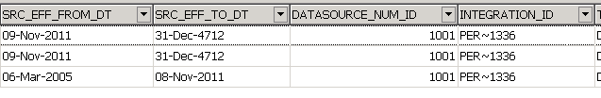

CREATE TABLE XXW_EMPLOYEE_DS_BAK20140327 as select * from W_EMPLOYEE_DS;

---Script----------

DECLARE

l_count NUMBER;

BEGIN

***DBMS_OUTPUT.put_line*** ('******************************Start ***************************');

for jj in (select count('X'),INTEGRATION_ID,DATASOURCE_NUM_ID,SRC_EFF_FROM_DT from PROD_DW.W_EMPLOYEE_DS group by INTEGRATION_ID,DATASOURCE_NUM_ID,SRC_EFF_FROM_DT having count('X') > 1) loop

FOR i IN (SELECT emp.ROWID ROW_ID,emp.* FROM PROD_DW.W_EMPLOYEE_DS emp where INTEGRATION_ID = jj.INTEGRATION_ID

AND DATASOURCE_NUM_ID = jj.DATASOURCE_NUM_ID

AND SRC_EFF_FROM_DT = jj.SRC_EFF_FROM_DT )

LOOP

l_count := 0;

SELECT COUNT ('X')

INTO l_count

FROM PROD_DW.W_EMPLOYEE_DS

WHERE INTEGRATION_ID = i.INTEGRATION_ID

AND DATASOURCE_NUM_ID = i.DATASOURCE_NUM_ID

AND SRC_EFF_FROM_DT = i.SRC_EFF_FROM_DT

group by INTEGRATION_ID,DATASOURCE_NUM_ID,SRC_EFF_FROM_DT;

IF l_count >1

THEN

DELETE FROM PROD_DW.W_EMPLOYEE_DS WHERE ROWID = i.ROW_ID;

l_count := 0;

***DBMS_OUTPUT.put_line*** ('FULL_NAME->'||i.FULL_NAME || ' INTEGRATION_ID ->' ||i.INTEGRATION_ID || ' DATASOURCE_NUM_ID->'||i.DATASOURCE_NUM_ID || ' SRC_EFF_FROM_DT-> '||i.SRC_EFF_FROM_DT);

*-- COMMIT;*

END IF;

END LOOP;

end loop;

***DBMS_OUTPUT.put_line*** ('****************************** End ***************************');

END;

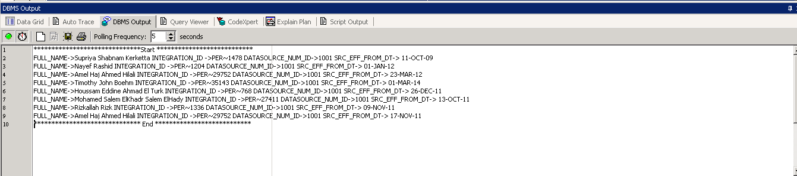

COMMIT;

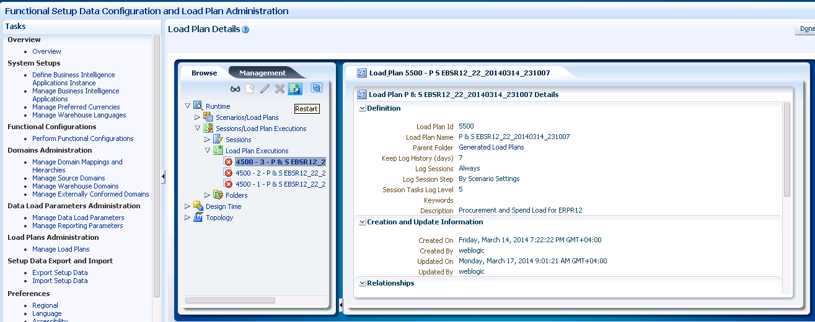

### 3.2.3 Duplicates in W_PRODUCT_ATTRIBS_D

After 7 minutes

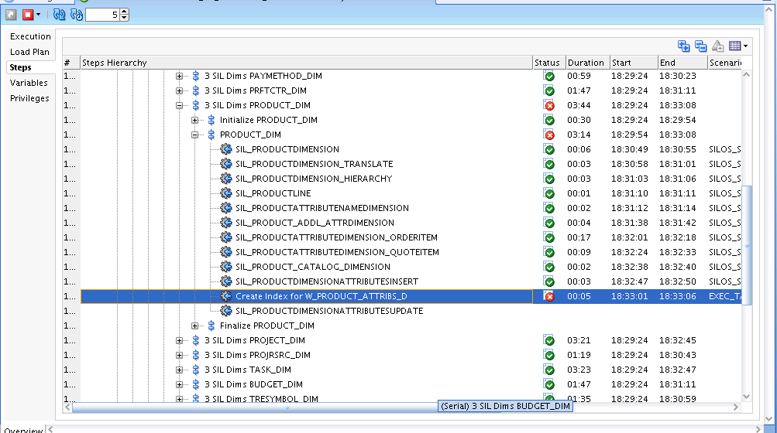

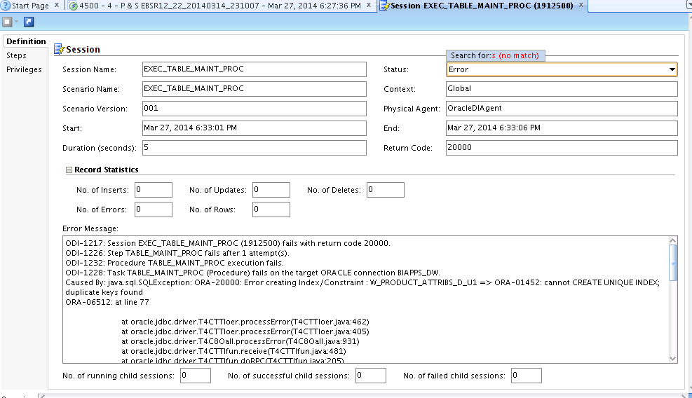

Unique index defined as following table

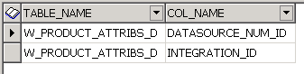

EXECUTE IMMEDIATE 'CREATE UNIQUE INDEX PROD_DW.W_PRODUCT_ATTRIBS_D_U1 ON PROD_DW.W_PRODUCT_ATTRIBS_D (INTEGRATION_ID,DATASOURCE_NUM_ID) NOLOGGING ';

select count('X'),INTEGRATION_ID,DATASOURCE_NUM_ID from PROD_DW.W_PRODUCT_ATTRIBS_D group by INTEGRATION_ID,DATASOURCE_NUM_ID having count('X') > 1;

COUNT('X') INTEGRATION_ID DATASOURCE_NUM_ID

2 4 1001

2 4042 1001

2 5 1001

2 4045 1001

2 7 1001

2 4043 1001

2 3 1001

2 4044 1001

2 2 1001

2 6 1001

2 4046 1001

CREATE TABLE PROD_DW.XXW_PRODUCT_ATTRIBS_D_BAK0327 as select * from PROD_DW.W_PRODUCT_ATTRIBS_D;

DECLARE

l_count NUMBER;

BEGIN

DBMS_OUTPUT.put_line ('******************************Start ***************************');

for jj in (select count('X'),INTEGRATION_ID,DATASOURCE_NUM_ID from PROD_DW.W_PRODUCT_ATTRIBS_D group by INTEGRATION_ID,DATASOURCE_NUM_ID having count('X') > 1) loop

FOR i IN (SELECT emp.ROWID ROW_ID,emp.* from PROD_DW.W_PRODUCT_ATTRIBS_D emp where INTEGRATION_ID = jj.INTEGRATION_ID

AND DATASOURCE_NUM_ID = jj.DATASOURCE_NUM_ID)

LOOP

l_count := 0;

SELECT COUNT ('X')

INTO l_count

FROM PROD_DW.W_PRODUCT_ATTRIBS_D

WHERE INTEGRATION_ID = i.INTEGRATION_ID

AND DATASOURCE_NUM_ID = i.DATASOURCE_NUM_ID

group by INTEGRATION_ID,DATASOURCE_NUM_ID;

IF l_count > 1

THEN

DELETE FROM PROD_DW.W_PRODUCT_ATTRIBS_D

WHERE ROWID = i.ROW_ID;

l_count := 0;

***DBMS_OUTPUT.put_line*** ('DATASOURCE_NUM_ID : '||i.DATASOURCE_NUM_ID ||' INTEGRATION_ID : '||i.INTEGRATION_ID);

END IF;

END LOOP;

end loop;

***DBMS_OUTPUT.put_line*** ('****************************** End ***************************');

END;

******************************Start ***************************

DATASOURCE_NUM_ID : 1001 INTEGRATION_ID : 4

DATASOURCE_NUM_ID : 1001 INTEGRATION_ID : 4042

DATASOURCE_NUM_ID : 1001 INTEGRATION_ID : 5

DATASOURCE_NUM_ID : 1001 INTEGRATION_ID : 4045

DATASOURCE_NUM_ID : 1001 INTEGRATION_ID : 7

DATASOURCE_NUM_ID : 1001 INTEGRATION_ID : 4043

DATASOURCE_NUM_ID : 1001 INTEGRATION_ID : 3

DATASOURCE_NUM_ID : 1001 INTEGRATION_ID : 4044

DATASOURCE_NUM_ID : 1001 INTEGRATION_ID : 2

DATASOURCE_NUM_ID : 1001 INTEGRATION_ID : 6

DATASOURCE_NUM_ID : 1001 INTEGRATION_ID : 4046

****************************** End ***************************

### 3.2.4 Duplicates in W_STATUS_D

1 minute

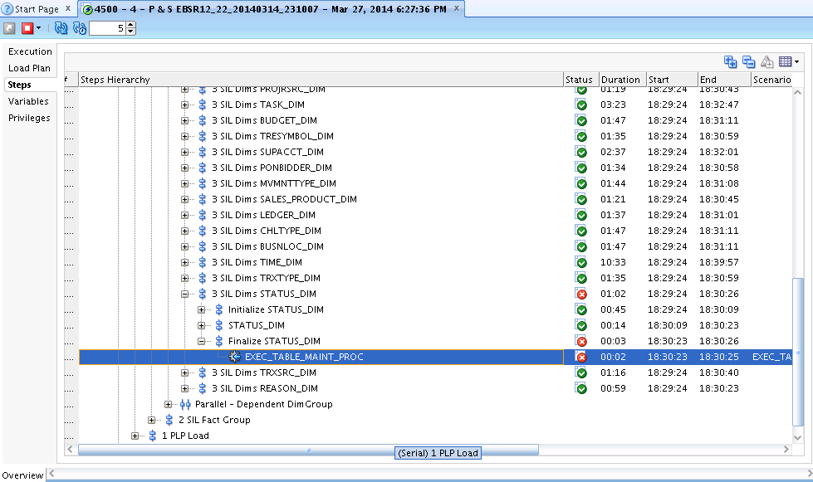

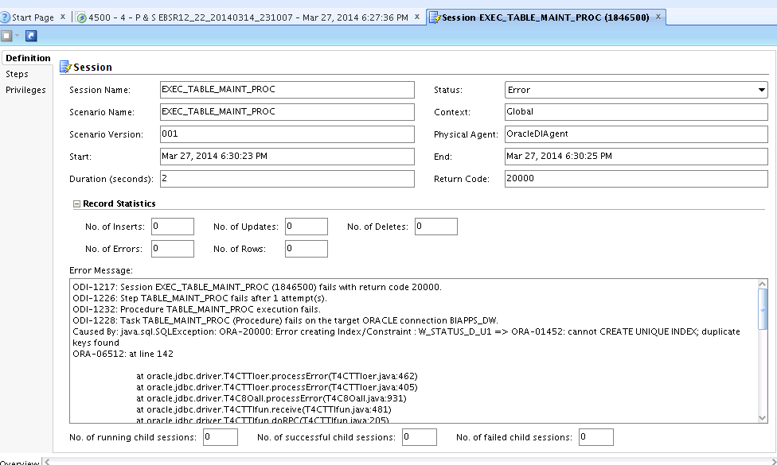

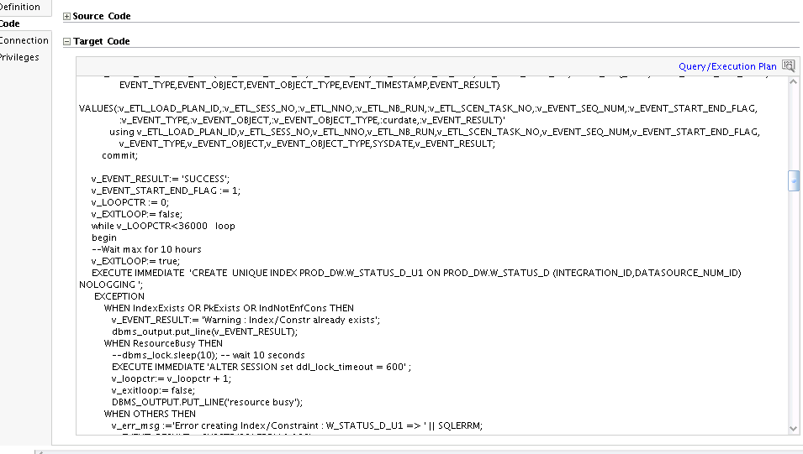

Unique index defined as following table

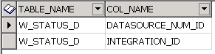

select count('X'),INTEGRATION_ID,DATASOURCE_NUM_ID from PROD_DW.W_STATUS_D group by INTEGRATION_ID,DATASOURCE_NUM_ID having count('X') > 1;

COUNT('X') INTEGRATION_ID DATASOURCE_NUM_ID

2 EXPENSE_PENDING_STATUS~MGRAPPR 1001

2 EXPENSE_PENDING_STATUS~SUBMITTED 1001

2 EXPENSE_PENDING_STATUS~SAVED 1001

2 EXPENSE_PENDING_STATUS~PARPAID 1001

2 EXPENSE_REPORT~PARPAID 1001

2 EXPENSE_PENDING_STATUS~MGRPAYAPPR 1001

2 EXPENSE_REPORT~PAID 1001

2 EXPENSE_REPORT~REJECTED 1001

2 EXPENSE_PENDING_STATUS~INVOICED 1001

2 EXPENSE_PENDING_STATUS~PAYAPPR 1001

2 EXPENSE_REPORT~MGRAPPR 1001

2 EXPENSE_PENDING_STATUS~PAID 1001

2 EXPENSE_PENDING_STATUS~REJECTED 1001

2 EXPENSE_REPORT~SUBMITTED 1001

2 EXPENSE_REPORT~PAYAPPR 1001

2 EXPENSE_REPORT~SAVED 1001

2 EXPENSE_REPORT~INVOICED 1001

2 EXPENSE_REPORT~MGRPAYAPPR 1001

CREATE TABLE XXW_STATUS_D_BAK20140327 as select * from W_STATUS_D;

DECLARE

l_count NUMBER;

BEGIN

DBMS_OUTPUT.put_line ('******************************Start ***************************');

for jj in (select count('X'),INTEGRATION_ID,DATASOURCE_NUM_ID from PROD_DW.W_STATUS_D group by INTEGRATION_ID,DATASOURCE_NUM_ID having count('X') > 1) loop

FOR i IN (SELECT emp.ROWID ROW_ID,emp.* from PROD_DW.W_STATUS_D emp where INTEGRATION_ID = jj.INTEGRATION_ID

AND DATASOURCE_NUM_ID = jj.DATASOURCE_NUM_ID)

LOOP

l_count := 0;

SELECT COUNT ('X')

INTO l_count

FROM PROD_DW.W_STATUS_D

WHERE INTEGRATION_ID = i.INTEGRATION_ID

AND DATASOURCE_NUM_ID = i.DATASOURCE_NUM_ID

group by INTEGRATION_ID,DATASOURCE_NUM_ID;

IF l_count > 1

THEN

DELETE FROM PROD_DW.W_STATUS_D

WHERE ROWID = i.ROW_ID;

l_count := 0;

***DBMS_OUTPUT.put_line*** ('DATASOURCE_NUM_ID : '||i.DATASOURCE_NUM_ID ||' INTEGRATION_ID : '||i.INTEGRATION_ID);

END IF;

END LOOP;

END LOOP;

***DBMS_OUTPUT.put_line*** ('****************************** End ***************************');

*-- COMMIT;*

END;

******************************Start ***************************

DATASOURCE_NUM_ID : 1001 INTEGRATION_ID : EXPENSE_PENDING_STATUS~MGRAPPR

DATASOURCE_NUM_ID : 1001 INTEGRATION_ID : EXPENSE_PENDING_STATUS~SUBMITTED

DATASOURCE_NUM_ID : 1001 INTEGRATION_ID : EXPENSE_PENDING_STATUS~SAVED

DATASOURCE_NUM_ID : 1001 INTEGRATION_ID : EXPENSE_PENDING_STATUS~PARPAID

DATASOURCE_NUM_ID : 1001 INTEGRATION_ID : EXPENSE_REPORT~PARPAID

DATASOURCE_NUM_ID : 1001 INTEGRATION_ID : EXPENSE_PENDING_STATUS~MGRPAYAPPR

DATASOURCE_NUM_ID : 1001 INTEGRATION_ID : EXPENSE_REPORT~PAID

DATASOURCE_NUM_ID : 1001 INTEGRATION_ID : EXPENSE_REPORT~REJECTED

DATASOURCE_NUM_ID : 1001 INTEGRATION_ID : EXPENSE_PENDING_STATUS~INVOICED

DATASOURCE_NUM_ID : 1001 INTEGRATION_ID : EXPENSE_PENDING_STATUS~PAYAPPR

DATASOURCE_NUM_ID : 1001 INTEGRATION_ID : EXPENSE_REPORT~MGRAPPR

DATASOURCE_NUM_ID : 1001 INTEGRATION_ID : EXPENSE_PENDING_STATUS~PAID

DATASOURCE_NUM_ID : 1001 INTEGRATION_ID : EXPENSE_PENDING_STATUS~REJECTED

DATASOURCE_NUM_ID : 1001 INTEGRATION_ID : EXPENSE_REPORT~SUBMITTED

DATASOURCE_NUM_ID : 1001 INTEGRATION_ID : EXPENSE_REPORT~PAYAPPR

DATASOURCE_NUM_ID : 1001 INTEGRATION_ID : EXPENSE_REPORT~SAVED

DATASOURCE_NUM_ID : 1001 INTEGRATION_ID : EXPENSE_REPORT~INVOICED

DATASOURCE_NUM_ID : 1001 INTEGRATION_ID : EXPENSE_REPORT~MGRPAYAPPR

****************************** End ***************************

COMMIT;

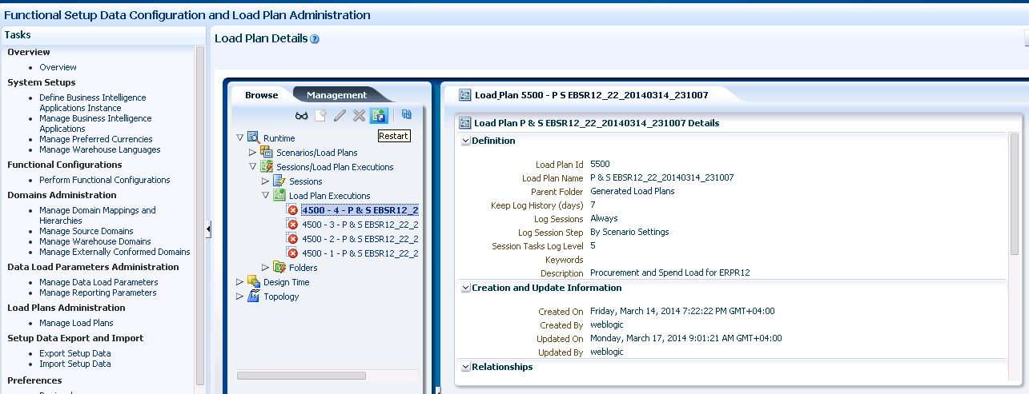

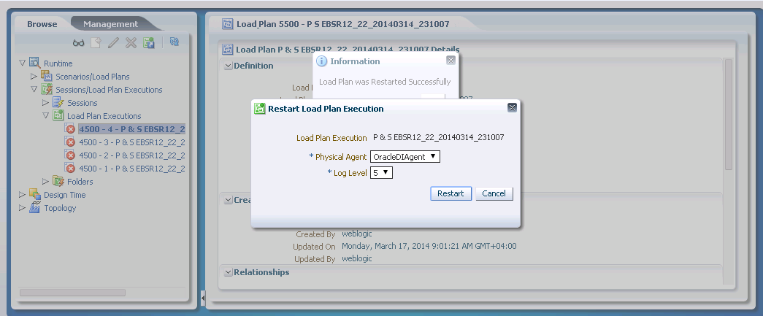

### 3.2.5 Duplicates in W_PRODUCT_D

1 minute

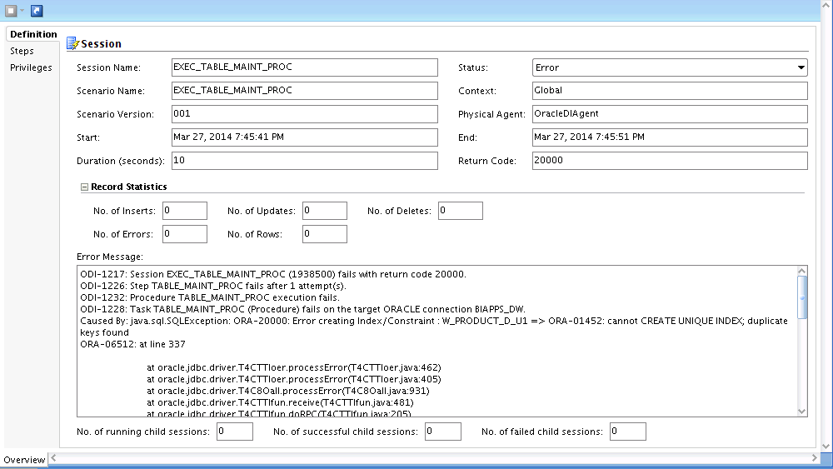

Unique index defined as following table

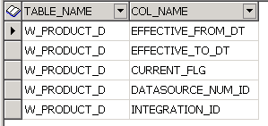

EXECUTE IMMEDIATE ‘CREATE UNWIUE INDEX PROD_DW.W_PRODUCT_D_U1 ON PROD_DW.W_PRODUCT_D (INTEGRATION_ID,DATASOURCE_NUM_ID,EFFECTIVE_FROM_DT,EFFECTIVE_TO_DT,CURRENT_FLG) NOLOGGING;

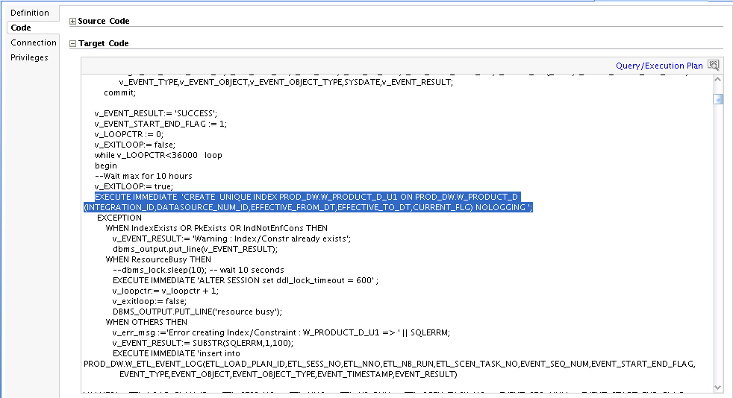

select count('X'),INTEGRATION_ID,DATASOURCE_NUM_ID,EFFECTIVE_FROM_DT,EFFECTIVE_TO_DT,CURRENT_FLG

from PROD_DW.W_PRODUCT_D group by INTEGRATION_ID,DATASOURCE_NUM_ID,EFFECTIVE_FROM_DT,EFFECTIVE_TO_DT,CURRENT_FLG having count('X') > 1;

COUNT('X') INTEGRATION_ID DATASOURCE_NUM_ID EFFECTIVE_FROM_DT EFFECTIVE_TO_DT CURRENT_FLG

4 4046 1001 1/1/1899 1/1/3714 Y

4 4043 1001 1/1/1899 1/1/3714 Y

4 2 1001 1/1/1899 1/1/3714 Y

4 4044 1001 1/1/1899 1/1/3714 Y

4 4 1001 1/1/1899 1/1/3714 Y

4 4042 1001 1/1/1899 1/1/3714 Y

4 7 1001 1/1/1899 1/1/3714 Y

4 6 1001 1/1/1899 1/1/3714 Y

4 5 1001 1/1/1899 1/1/3714 Y

4 3 1001 1/1/1899 1/1/3714 Y

4 4045 1001 1/1/1899 1/1/3714 Y

CREATE TABLE XXW_PRODUCT_D_BAK20140327 as select * from W_PRODUCT_D;

DECLARE

l_count NUMBER;

BEGIN

***DBMS_OUTPUT.put_line*** ('******************************Start ***************************');

for jj in (select count('X'), INTEGRATION_ID,DATASOURCE_NUM_ID,EFFECTIVE_FROM_DT,EFFECTIVE_TO_DT,CURRENT_FLG from

PROD_DW.W_PRODUCT_D

group by INTEGRATION_ID,DATASOURCE_NUM_ID,EFFECTIVE_FROM_DT,EFFECTIVE_TO_DT,CURRENT_FLG having count('X') > 1) loop

FOR i IN (SELECT emp.ROWID ROW_ID,emp.* FROM PROD_DW.W_PRODUCT_D emp where INTEGRATION_ID = jj.INTEGRATION_ID

AND DATASOURCE_NUM_ID = jj.DATASOURCE_NUM_ID

AND EFFECTIVE_FROM_DT = jj.EFFECTIVE_FROM_DT

AND EFFECTIVE_TO_DT = jj.EFFECTIVE_TO_DT

AND CURRENT_FLG = jj.CURRENT_FLG)

LOOP

l_count := 0;

SELECT COUNT ('X')

INTO l_count

FROM PROD_DW.W_PRODUCT_D

WHERE INTEGRATION_ID = i.INTEGRATION_ID

AND DATASOURCE_NUM_ID = i.DATASOURCE_NUM_ID

AND EFFECTIVE_FROM_DT = i.EFFECTIVE_FROM_DT

AND EFFECTIVE_TO_DT = i.EFFECTIVE_TO_DT

AND CURRENT_FLG = i.CURRENT_FLG

group by INTEGRATION_ID,DATASOURCE_NUM_ID,EFFECTIVE_FROM_DT,EFFECTIVE_TO_DT,CURRENT_FLG;

IF l_count >1

THEN

DELETE FROM PROD_DW. W_PRODUCT_D WHERE ROWID = i.ROW_ID;

l_count := 0;

***DBMS_OUTPUT.put_line*** (' INTEGRATION_ID ->' ||i.INTEGRATION_ID || ' DATASOURCE_NUM_ID->'||i.DATASOURCE_NUM_ID || ' EFFECTIVE_FROM_DT-> '||i.EFFECTIVE_FROM_DT || ' EFFECTIVE_TO_DT-> '||i.EFFECTIVE_TO_DT|| ' CURRENT_FLG -> '||i.CURRENT_FLG);

*-- COMMIT;*

END IF;

END LOOP;

end loop;

***DBMS_OUTPUT.put_line*** ('****************************** End ***************************');

END;

******************************Start ***************************

INTEGRATION_ID ->4046 DATASOURCE_NUM_ID->1001 EFFECTIVE_FROM_DT-> 01-JAN-99 EFFECTIVE_TO_DT-> 01-JAN-14 CURRENT_FLG -> Y

INTEGRATION_ID ->4046 DATASOURCE_NUM_ID->1001 EFFECTIVE_FROM_DT-> 01-JAN-99 EFFECTIVE_TO_DT-> 01-JAN-14 CURRENT_FLG -> Y

INTEGRATION_ID ->4046 DATASOURCE_NUM_ID->1001 EFFECTIVE_FROM_DT-> 01-JAN-99 EFFECTIVE_TO_DT-> 01-JAN-14 CURRENT_FLG -> Y

INTEGRATION_ID ->4043 DATASOURCE_NUM_ID->1001 EFFECTIVE_FROM_DT-> 01-JAN-99 EFFECTIVE_TO_DT-> 01-JAN-14 CURRENT_FLG -> Y

INTEGRATION_ID ->4043 DATASOURCE_NUM_ID->1001 EFFECTIVE_FROM_DT-> 01-JAN-99 EFFECTIVE_TO_DT-> 01-JAN-14 CURRENT_FLG -> Y

INTEGRATION_ID ->4043 DATASOURCE_NUM_ID->1001 EFFECTIVE_FROM_DT-> 01-JAN-99 EFFECTIVE_TO_DT-> 01-JAN-14 CURRENT_FLG -> Y

INTEGRATION_ID ->2 DATASOURCE_NUM_ID->1001 EFFECTIVE_FROM_DT-> 01-JAN-99 EFFECTIVE_TO_DT-> 01-JAN-14 CURRENT_FLG -> Y

INTEGRATION_ID ->2 DATASOURCE_NUM_ID->1001 EFFECTIVE_FROM_DT-> 01-JAN-99 EFFECTIVE_TO_DT-> 01-JAN-14 CURRENT_FLG -> Y

INTEGRATION_ID ->2 DATASOURCE_NUM_ID->1001 EFFECTIVE_FROM_DT-> 01-JAN-99 EFFECTIVE_TO_DT-> 01-JAN-14 CURRENT_FLG -> Y

INTEGRATION_ID ->4044 DATASOURCE_NUM_ID->1001 EFFECTIVE_FROM_DT-> 01-JAN-99 EFFECTIVE_TO_DT-> 01-JAN-14 CURRENT_FLG -> Y

INTEGRATION_ID ->4044 DATASOURCE_NUM_ID->1001 EFFECTIVE_FROM_DT-> 01-JAN-99 EFFECTIVE_TO_DT-> 01-JAN-14 CURRENT_FLG -> Y

INTEGRATION_ID ->4044 DATASOURCE_NUM_ID->1001 EFFECTIVE_FROM_DT-> 01-JAN-99 EFFECTIVE_TO_DT-> 01-JAN-14 CURRENT_FLG -> Y

INTEGRATION_ID ->4 DATASOURCE_NUM_ID->1001 EFFECTIVE_FROM_DT-> 01-JAN-99 EFFECTIVE_TO_DT-> 01-JAN-14 CURRENT_FLG -> Y

INTEGRATION_ID ->4 DATASOURCE_NUM_ID->1001 EFFECTIVE_FROM_DT-> 01-JAN-99 EFFECTIVE_TO_DT-> 01-JAN-14 CURRENT_FLG -> Y

INTEGRATION_ID ->4 DATASOURCE_NUM_ID->1001 EFFECTIVE_FROM_DT-> 01-JAN-99 EFFECTIVE_TO_DT-> 01-JAN-14 CURRENT_FLG -> Y

INTEGRATION_ID ->4042 DATASOURCE_NUM_ID->1001 EFFECTIVE_FROM_DT-> 01-JAN-99 EFFECTIVE_TO_DT-> 01-JAN-14 CURRENT_FLG -> Y

INTEGRATION_ID ->4042 DATASOURCE_NUM_ID->1001 EFFECTIVE_FROM_DT-> 01-JAN-99 EFFECTIVE_TO_DT-> 01-JAN-14 CURRENT_FLG -> Y

INTEGRATION_ID ->4042 DATASOURCE_NUM_ID->1001 EFFECTIVE_FROM_DT-> 01-JAN-99 EFFECTIVE_TO_DT-> 01-JAN-14 CURRENT_FLG -> Y

INTEGRATION_ID ->7 DATASOURCE_NUM_ID->1001 EFFECTIVE_FROM_DT-> 01-JAN-99 EFFECTIVE_TO_DT-> 01-JAN-14 CURRENT_FLG -> Y

INTEGRATION_ID ->7 DATASOURCE_NUM_ID->1001 EFFECTIVE_FROM_DT-> 01-JAN-99 EFFECTIVE_TO_DT-> 01-JAN-14 CURRENT_FLG -> Y

INTEGRATION_ID ->7 DATASOURCE_NUM_ID->1001 EFFECTIVE_FROM_DT-> 01-JAN-99 EFFECTIVE_TO_DT-> 01-JAN-14 CURRENT_FLG -> Y

INTEGRATION_ID ->6 DATASOURCE_NUM_ID->1001 EFFECTIVE_FROM_DT-> 01-JAN-99 EFFECTIVE_TO_DT-> 01-JAN-14 CURRENT_FLG -> Y

INTEGRATION_ID ->6 DATASOURCE_NUM_ID->1001 EFFECTIVE_FROM_DT-> 01-JAN-99 EFFECTIVE_TO_DT-> 01-JAN-14 CURRENT_FLG -> Y

INTEGRATION_ID ->6 DATASOURCE_NUM_ID->1001 EFFECTIVE_FROM_DT-> 01-JAN-99 EFFECTIVE_TO_DT-> 01-JAN-14 CURRENT_FLG -> Y

INTEGRATION_ID ->5 DATASOURCE_NUM_ID->1001 EFFECTIVE_FROM_DT-> 01-JAN-99 EFFECTIVE_TO_DT-> 01-JAN-14 CURRENT_FLG -> Y

INTEGRATION_ID ->5 DATASOURCE_NUM_ID->1001 EFFECTIVE_FROM_DT-> 01-JAN-99 EFFECTIVE_TO_DT-> 01-JAN-14 CURRENT_FLG -> Y

INTEGRATION_ID ->5 DATASOURCE_NUM_ID->1001 EFFECTIVE_FROM_DT-> 01-JAN-99 EFFECTIVE_TO_DT-> 01-JAN-14 CURRENT_FLG -> Y

INTEGRATION_ID ->3 DATASOURCE_NUM_ID->1001 EFFECTIVE_FROM_DT-> 01-JAN-99 EFFECTIVE_TO_DT-> 01-JAN-14 CURRENT_FLG -> Y

INTEGRATION_ID ->3 DATASOURCE_NUM_ID->1001 EFFECTIVE_FROM_DT-> 01-JAN-99 EFFECTIVE_TO_DT-> 01-JAN-14 CURRENT_FLG -> Y

INTEGRATION_ID ->3 DATASOURCE_NUM_ID->1001 EFFECTIVE_FROM_DT-> 01-JAN-99 EFFECTIVE_TO_DT-> 01-JAN-14 CURRENT_FLG -> Y

INTEGRATION_ID ->4045 DATASOURCE_NUM_ID->1001 EFFECTIVE_FROM_DT-> 01-JAN-99 EFFECTIVE_TO_DT-> 01-JAN-14 CURRENT_FLG -> Y

INTEGRATION_ID ->4045 DATASOURCE_NUM_ID->1001 EFFECTIVE_FROM_DT-> 01-JAN-99 EFFECTIVE_TO_DT-> 01-JAN-14 CURRENT_FLG -> Y

INTEGRATION_ID ->4045 DATASOURCE_NUM_ID->1001 EFFECTIVE_FROM_DT-> 01-JAN-99 EFFECTIVE_TO_DT-> 01-JAN-14 CURRENT_FLG -> Y

****************************** End ***************************

COMMIT;

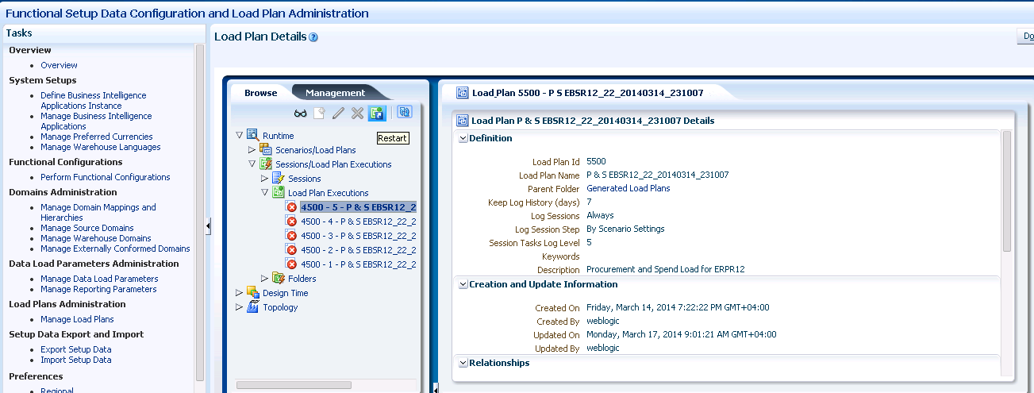

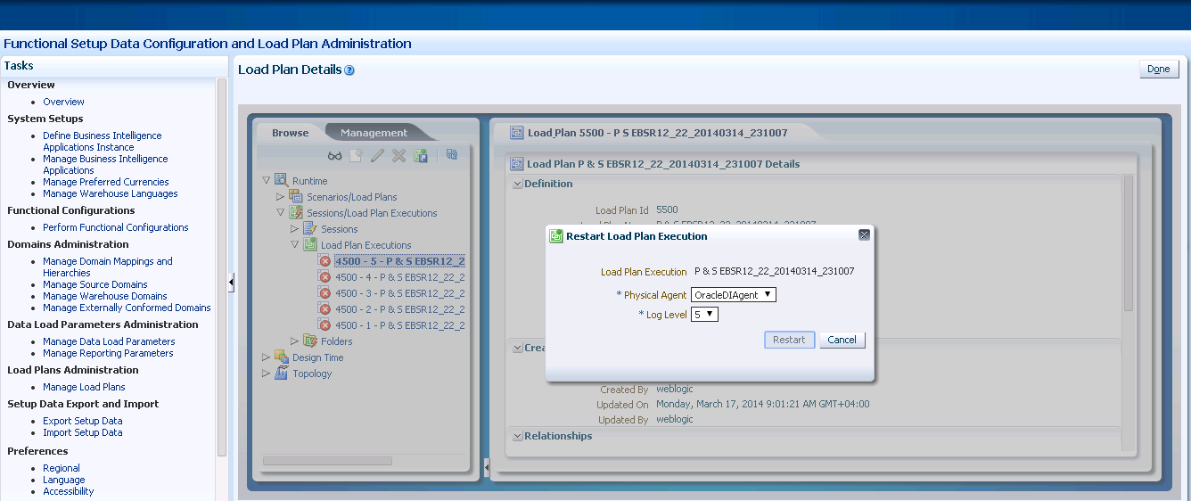

### 3.2.6 Duplicates in W_PROC_PROD_D

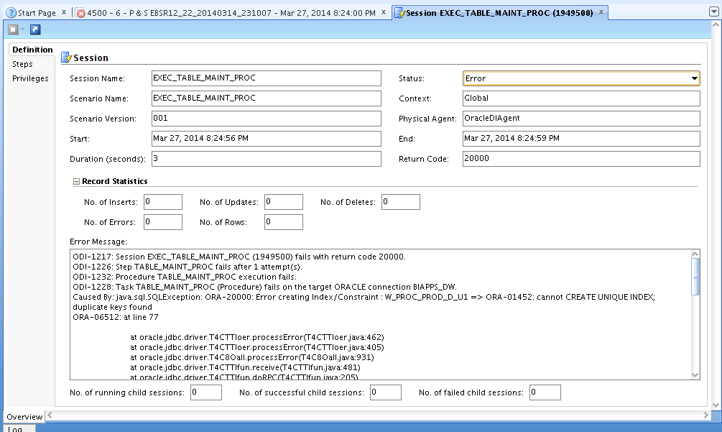

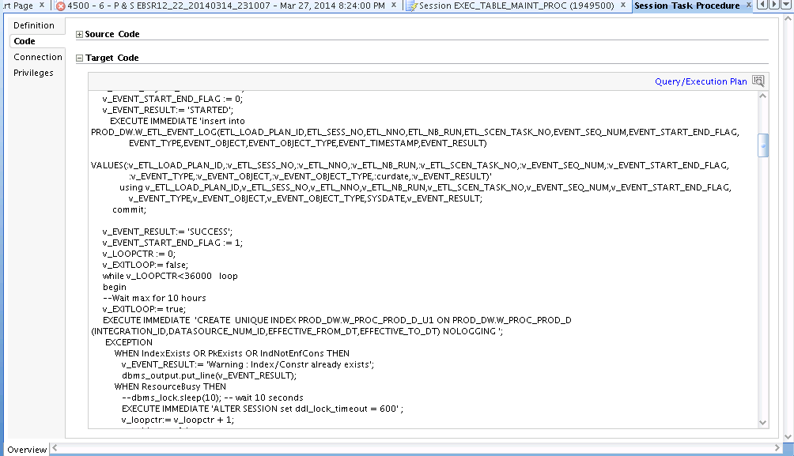

Unique index defined as following table

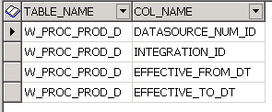

EXECUTE IMMEDIATE 'CREATE UNIQUE INDEX PROD_DW.W_PROC_PROD_D_U1 ON PROD_DW.W_PROC_PROD_D (INTEGRATION_ID,DATASOURCE_NUM_ID,EFFECTIVE_FROM_DT,EFFECTIVE_TO_DT) NOLOGGING ';

select count('X'),INTEGRATION_ID,DATASOURCE_NUM_ID,EFFECTIVE_FROM_DT,EFFECTIVE_TO_DT

from PROD_DW.W_PROC_PROD_D group by INTEGRATION_ID,DATASOURCE_NUM_ID,EFFECTIVE_FROM_DT,EFFECTIVE_TO_DT having count('X') > 1;

COUNT('X') INTEGRATION_ID DATASOURCE_NUM_ID EFFECTIVE_FROM_DT EFFECTIVE_TO_DT

2 2d70d39ca6aa7dd5910f6f59be59f9cf 1001 1/1/1899 1/1/3714

2 8b7c84e7c90d5bbeae94e040fd892c29 1001 1/1/1899 1/1/3714

2 8d213884f30a8fa4a572a5eabd75f6a4 1001 1/1/1899 1/1/3714

2 f7c3df1f377f77340e3fa2a85ecc63d0 1001 1/1/1899 1/1/3714

2 a2e4b00a55880903ea798a59f780eb61 1001 1/1/1899 1/1/3714

2 68f5e930cc87ce22e7e38cf22ef6887d 1001 1/1/1899 1/1/3714

2 6b1c8d057fa4f9b38551b0ca1f677fb8 1001 1/1/1899 1/1/3714

2 d15b84513304495da9b5f2fefdcccdcd 1001 1/1/1899 1/1/3714

2 262f3dc1526e4d8315efd65c156d4a55 1001 1/1/1899 1/1/3714

2 01b939fa9cca48f42265fecb1ae910d7 1001 1/1/1899 1/1/3714

2 498c19e9428e18306885a19305d076ab 1001 1/1/1899 1/1/3714

CREATE TABLE XXW_PROC_PROD_D_BAK20140327 as select * from W_PROC_PROD_D;

DECLARE

l_count NUMBER;

BEGIN

***DBMS_OUTPUT.put_line*** ('******************************Start ***************************');

for jj in (select count('X'), INTEGRATION_ID,DATASOURCE_NUM_ID,EFFECTIVE_FROM_DT,EFFECTIVE_TO_DT from

PROD_DW.W_PROC_PROD_D

group by INTEGRATION_ID,DATASOURCE_NUM_ID,EFFECTIVE_FROM_DT,EFFECTIVE_TO_DT having count('X') > 1) loop

FOR i IN (SELECT emp.ROWID ROW_ID,emp.* FROM PROD_DW.W_PROC_PROD_D emp where INTEGRATION_ID = jj.INTEGRATION_ID

AND DATASOURCE_NUM_ID = jj.DATASOURCE_NUM_ID

AND EFFECTIVE_FROM_DT = jj.EFFECTIVE_FROM_DT

AND EFFECTIVE_TO_DT = jj.EFFECTIVE_TO_DT)

LOOP

l_count := 0;

SELECT COUNT ('X')

INTO l_count

FROM PROD_DW.W_PROC_PROD_D

WHERE INTEGRATION_ID = i.INTEGRATION_ID

AND DATASOURCE_NUM_ID = i.DATASOURCE_NUM_ID

AND EFFECTIVE_FROM_DT = i.EFFECTIVE_FROM_DT

AND EFFECTIVE_TO_DT = i.EFFECTIVE_TO_DT

group by INTEGRATION_ID,DATASOURCE_NUM_ID,EFFECTIVE_FROM_DT,EFFECTIVE_TO_DT,CURRENT_FLG;

IF l_count >1

THEN

DELETE FROM PROD_DW. W_PROC_PROD_D WHERE ROWID = i.ROW_ID;

l_count := 0;

***DBMS_OUTPUT.put_line*** (' INTEGRATION_ID ->' ||i.INTEGRATION_ID || ' DATASOURCE_NUM_ID->'||i.DATASOURCE_NUM_ID || ' EFFECTIVE_FROM_DT-> '||i.EFFECTIVE_FROM_DT || ' EFFECTIVE_TO_DT-> '||i.EFFECTIVE_TO_DT);

*-- COMMIT;*

END IF;

END LOOP;

end loop;

***DBMS_OUTPUT.put_line*** ('****************************** End ***************************');

END;

******************************Start ***************************

INTEGRATION_ID ->2d70d39ca6aa7dd5910f6f59be59f9cf DATASOURCE_NUM_ID->1001 EFFECTIVE_FROM_DT-> 01-JAN-99 EFFECTIVE_TO_DT-> 01-JAN-14

INTEGRATION_ID ->8b7c84e7c90d5bbeae94e040fd892c29 DATASOURCE_NUM_ID->1001 EFFECTIVE_FROM_DT-> 01-JAN-99 EFFECTIVE_TO_DT-> 01-JAN-14

INTEGRATION_ID ->8d213884f30a8fa4a572a5eabd75f6a4 DATASOURCE_NUM_ID->1001 EFFECTIVE_FROM_DT-> 01-JAN-99 EFFECTIVE_TO_DT-> 01-JAN-14

INTEGRATION_ID ->f7c3df1f377f77340e3fa2a85ecc63d0 DATASOURCE_NUM_ID->1001 EFFECTIVE_FROM_DT-> 01-JAN-99 EFFECTIVE_TO_DT-> 01-JAN-14

INTEGRATION_ID ->a2e4b00a55880903ea798a59f780eb61 DATASOURCE_NUM_ID->1001 EFFECTIVE_FROM_DT-> 01-JAN-99 EFFECTIVE_TO_DT-> 01-JAN-14

INTEGRATION_ID ->68f5e930cc87ce22e7e38cf22ef6887d DATASOURCE_NUM_ID->1001 EFFECTIVE_FROM_DT-> 01-JAN-99 EFFECTIVE_TO_DT-> 01-JAN-14

INTEGRATION_ID ->6b1c8d057fa4f9b38551b0ca1f677fb8 DATASOURCE_NUM_ID->1001 EFFECTIVE_FROM_DT-> 01-JAN-99 EFFECTIVE_TO_DT-> 01-JAN-14

INTEGRATION_ID ->d15b84513304495da9b5f2fefdcccdcd DATASOURCE_NUM_ID->1001 EFFECTIVE_FROM_DT-> 01-JAN-99 EFFECTIVE_TO_DT-> 01-JAN-14

INTEGRATION_ID ->262f3dc1526e4d8315efd65c156d4a55 DATASOURCE_NUM_ID->1001 EFFECTIVE_FROM_DT-> 01-JAN-99 EFFECTIVE_TO_DT-> 01-JAN-14

INTEGRATION_ID ->01b939fa9cca48f42265fecb1ae910d7 DATASOURCE_NUM_ID->1001 EFFECTIVE_FROM_DT-> 01-JAN-99 EFFECTIVE_TO_DT-> 01-JAN-14

INTEGRATION_ID ->498c19e9428e18306885a19305d076ab DATASOURCE_NUM_ID->1001 EFFECTIVE_FROM_DT-> 01-JAN-99 EFFECTIVE_TO_DT-> 01-JAN-14

****************************** End ***************************

COMMIT;

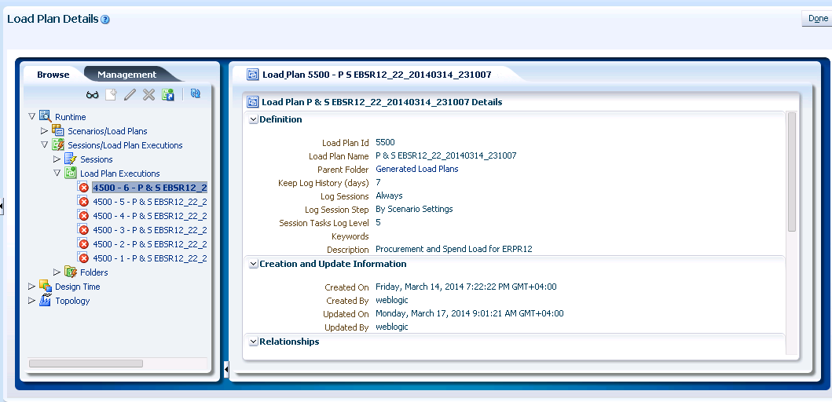

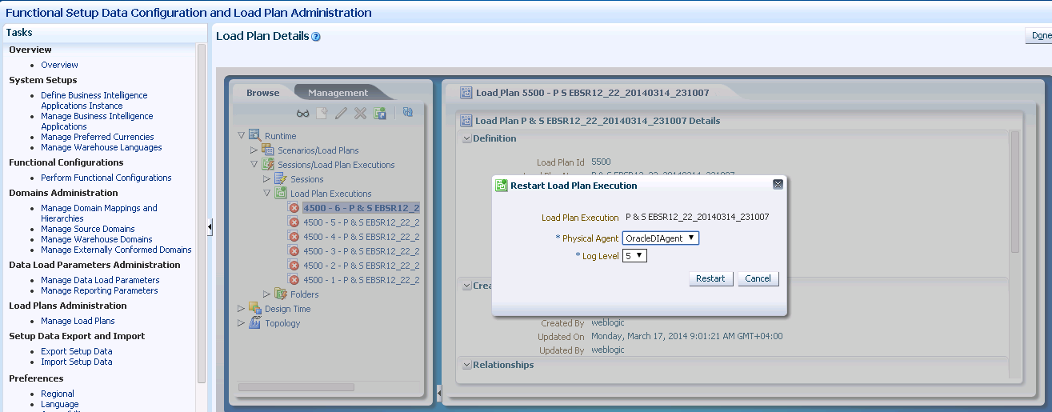

# TEMP Table Space full

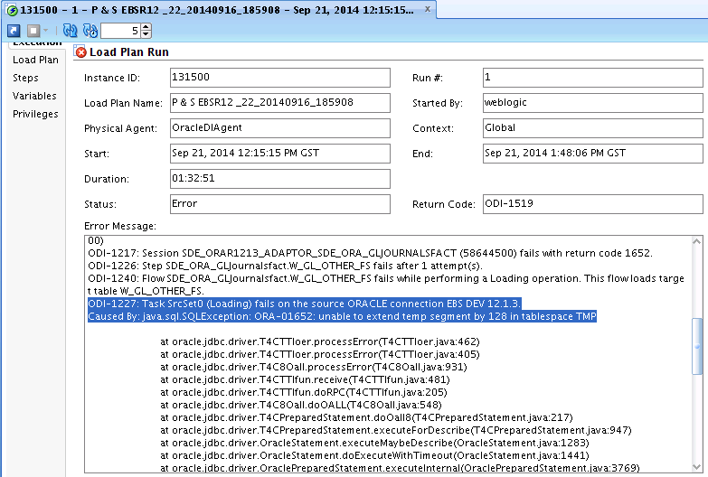

When this error/exception occurred, we need to verify the temp table space free space and used and add another temp file into DWH table space. Following are the DDL/DML are required to do this.

SELECT d.status "Status", d.tablespace_name "Name", d.contents "Type", d.extent_management "ExtManag",

TO_CHAR(NVL(a.bytes / 1024 / 1024, 0),'99,999,990.900') "Size (M)", TO_CHAR(NVL(t.bytes,0)/1024/1024,'99999,999.999') ||'/'||TO_CHAR(NVL(a.bytes/1024/1024, 0),'99999,999.999') "Used (M)",

TO_CHAR(NVL(t.bytes / a.bytes * 100, 0), '990.00') "Used %"

FROM sys.dba_tablespaces d, (select tablespace_name, sum(bytes) bytes from dba_temp_files group by

tablespace_name) a,

(select tablespace_name, sum(bytes_cached) bytes from

v$temp_extent_pool group by tablespace_name) t

WHERE d.tablespace_name = a.tablespace_name(+) AND d.tablespace_name = t.tablespace_name(+)

AND d.extent_management like 'LOCAL' AND d.contents like 'TEMPORARY';

This select statement shows the following results with different values.

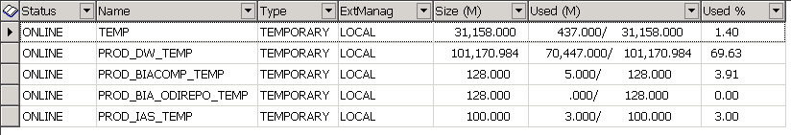

To add new add another table space temp file to database, use the following script.

alter tablespace PROD_DW_TEMP add tempfile '/erpsso/BI/db/oradata/bidb/BIDB/**PROD_dwtemp05.dbf**' size 30G autoextend on;

NOTE: Remember to change the PROD_dwtemp05.dbf filename, as it is already exist.

# End of Full Load

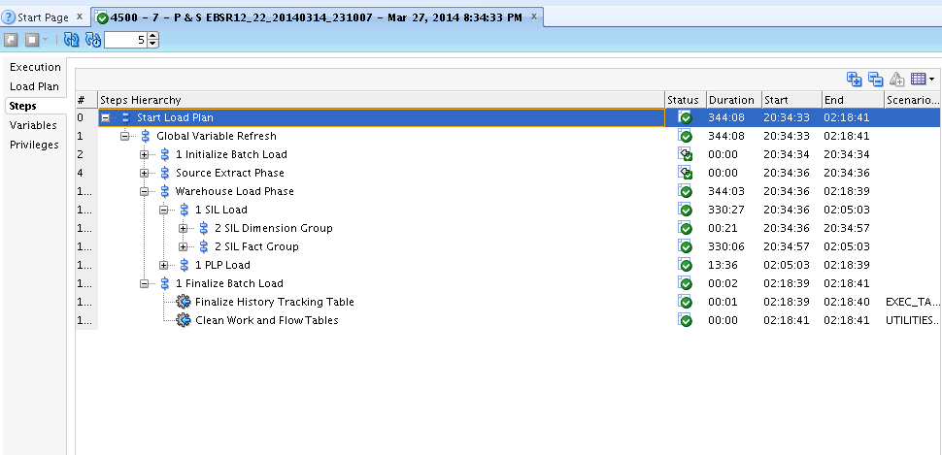

# Checking the execution of the customized tasks

## 6.1 SDE PROCPO Fact Group

SDE_ORA_PurchaseCostFact

SDE_ORA_PurchaseScheduleLinesFact

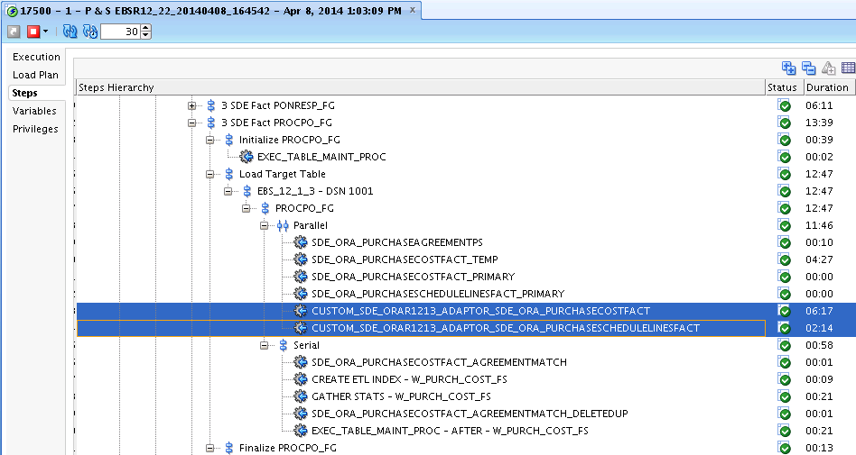

## 6.2 SDE PURAGG Fact Group

SDE_ORA_PurchaseAgreementLineFact

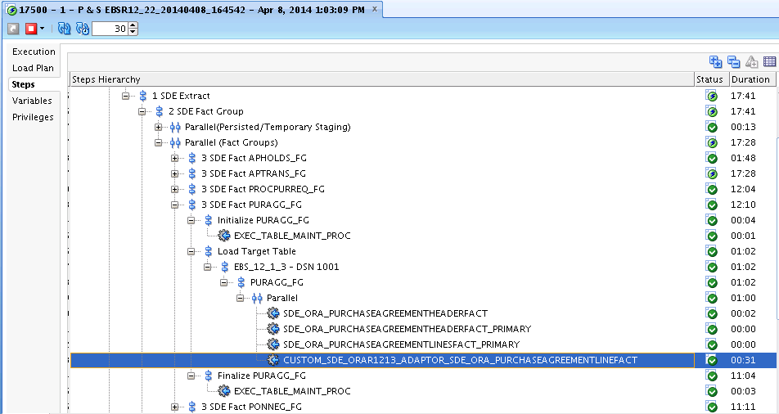

## 6.3 SDE OP Fact Group

SDE_ORA_PurchaseAgreementScheduleLinesFact

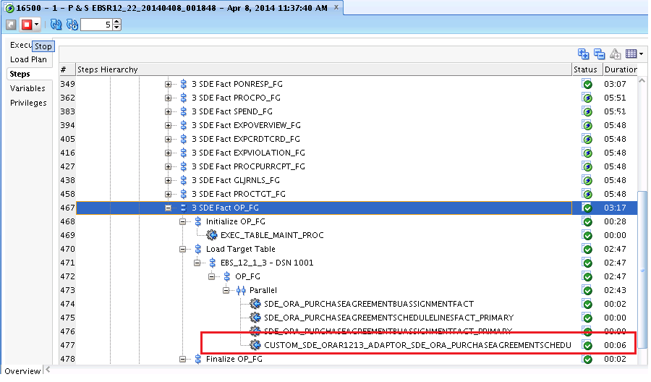

## 6.4 SDE PROCPURRCPT Fact Group

SDE_ORA_PurchaseReceiptFact

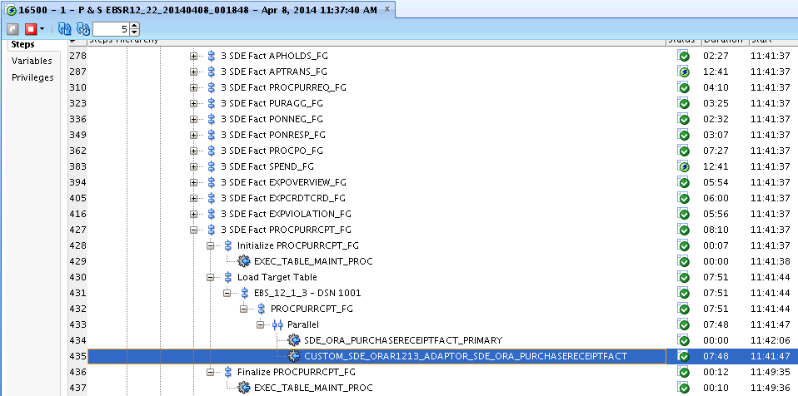

## 6.5 SDE PROCPURREQ Fact Group

SDE_ORA_PurchaseRequisitionLinesFact

SDE_ORA_RequisitionLinesCostFact

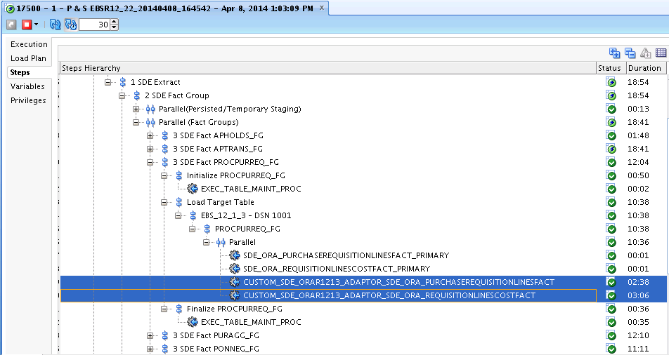

## 6.6 SIL PROCPO Fact Group

SIL_PurchaseCostFact (Original Promised Date, Savings attributes)

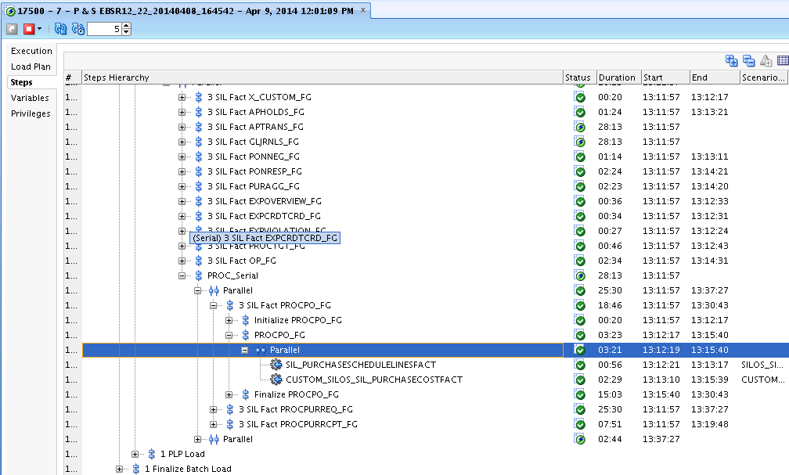

## 6.7 SIL PROCPURREQ Fact Group

SIL_RequisitionLinesCostFact (Purchase Type DFF,

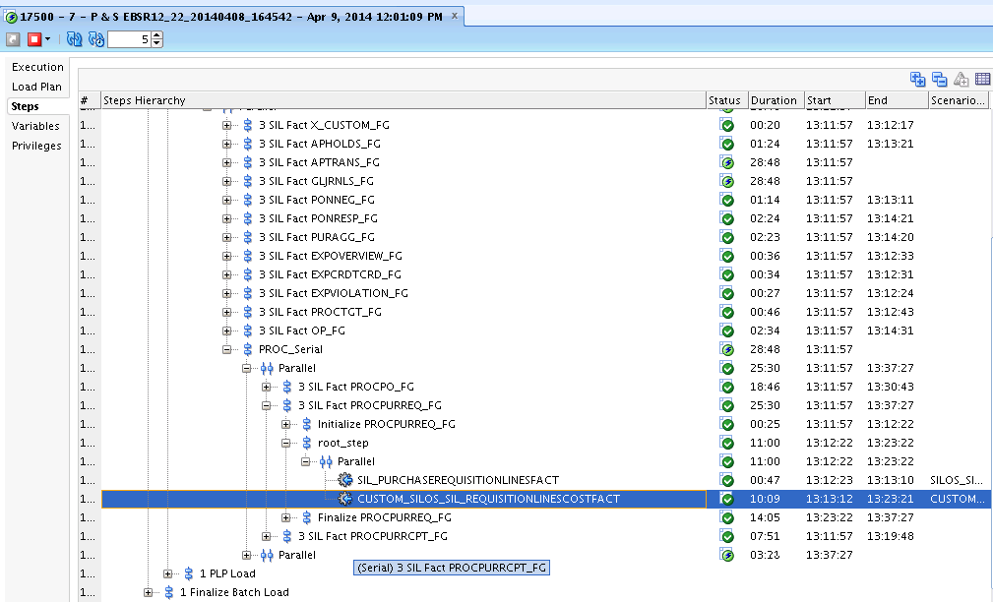

## 6.8 SIL PROCPURCY Fact Group

SIL_PurchaseCycleLinesFact

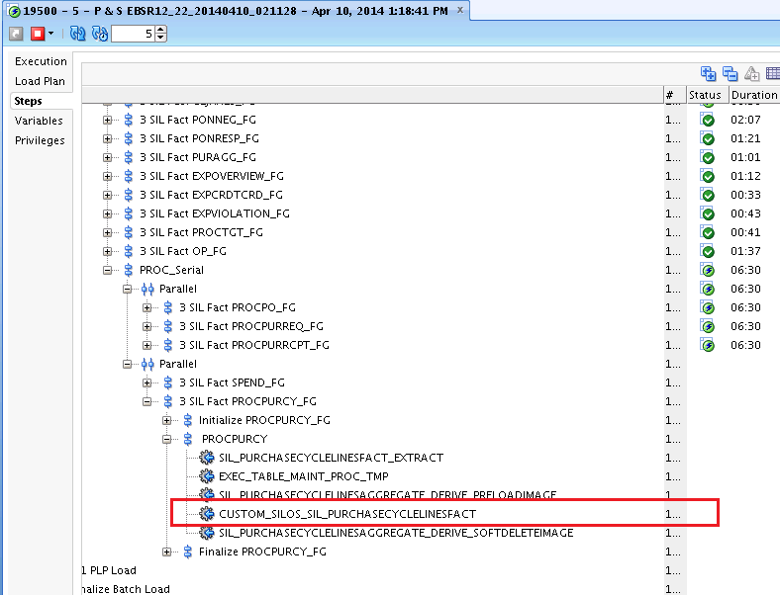

# Purchase Cost Fact Obtain the Original Promised Date

After verifying and validation, and successful full load, execute the above task separately, this will not take more than 2 minutes.